

PRESS RELEASE

PEUGEOT UPGRADES LANDTREK WITH NEW 2.2-LITRE MULTIJET TURBODIESEL, MORE CAPABILITY AND ENHANCED TECHNOLOGY

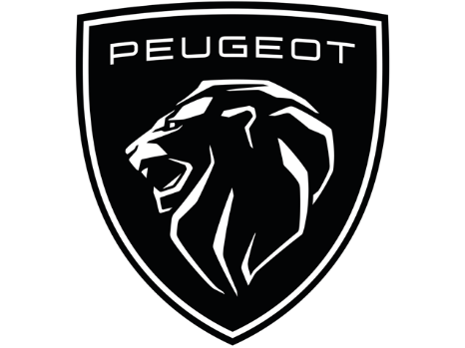

October 08, 2026

PEUGEOT UPGRADES LANDTREK WITH NEW 2.2-LITRE MULTIJET TURBODIESEL, MORE CAPABILITY AND ENHANCED TECHNOLOGY

PEUGEOT, part of Stellantis South Africa, has expanded its Landtrek range with the introduction of a new 147 kW / 450 Nm 2.2-litre Multijet turbodiesel-powered derivative, delivering increased towing capability, enhanced technology and additional safety features.

Available in Double Cab Allure and 4Action derivatives, the updated Landtrek builds on the model’s proven capability and practicality to deliver greater performance, comfort and value for customers who rely on their bakkie for work and everyday life. Sales commence in October 2026.

The introduction of the new derivatives reflects PEUGEOT South Africa's continued focus on strengthening its position in the highly competitive one-ton bakkie segment. The latest updates enhance the Landtrek's performance, technology and safety while retaining the practicality and capability that customers value.

More power. Greater capability.
The Landtrek is powered by a new 2.2-litre Multijet turbodiesel engine, producing 147 kW and 450 Nm of torque. Paired with an eight-speed automatic transmission featuring an electronic gear selector (e-shifter), the new powertrain produces 37 kW more power and 100 Nm more torque than the current 1.9-litre turbodiesel engine, while increasing maximum towing capacity from 3 000 kg to 3 500 kg.

Inside, the Landtrek features an updated digital instrument cluster and infotainment system, bringing a more contemporary feel to the cabin. Wireless Apple CarPlay® and Android Auto™ are now available, while an electronic parking brake has also been added.

Smarter technology. Greater confidence.
New driver assistance technologies include Lane Departure Warning, Adaptive Cruise Control and Blind Spot Detection, providing greater confidence and convenience behind the wheel.

"The Landtrek has established itself as a capable, dependable and versatile bakkie, and these latest enhancements take it to the next level," says Moeketsi Mapogo, Brand Head: Pro One LCV at Stellantis South Africa. "We know our customers rely on their bakkies every day, so we’ve focused on the updates that will make the biggest difference in how they use them. The result is a Landtrek that stays true to its strengths while offering customers even greater value.”

The new PEUGEOT Landtrek Double Cab Allure and 4Action models will be available from R666,900 at PEUGEOT dealerships nationwide from 08 October 2026.

For more information visit PEUGEOT.

-ends-

PRESS CONTACTS
sizwekazi.mdingi@stellantis.com

LINKS
PEUGEOT Press Site
https://www.media.stellantis.com/em-en/peugeot

ABOUT PEUGEOT
PEUGEOT offers the widest EV lineup of any European mainstream brand, covering all needs from urban cars to commercial vehicles. The French charisma, the driving sensations and the Designed to last constitute the brand values of PEUGEOT. Established in over 140 countries, PEUGEOT sold almost 1.1 million vehicles worldwide in 2024. Already the leader in electric B-segment and LCV vehicles in Europe, PEUGEOT is now offering a complete lineup of 12 models, of which 9 Passenger cars and 3 LCV. PEUGEOT offers 8 years/160,000 km Peugeot Care warranty on the battery and the vehicle, as well as the On-the-go Pass on all its electric passenger cars for complete peace of mind. PEUGEOT products incorporate the latest technology, showcased by the Panoramic i-Cockpit and ChatGPT on board across the entire range. PEUGEOT is also committed to educating younger generations by supporting initiatives such as Born Free and Under The Pole to bring them closer to nature. Furthermore, PEUGEOT's passion for performance and innovation is showcased through the PEUGEOT 9X8 Hypercar, which competes in the World Endurance Championship (WEC), including the 24 Hours of Le Mans.


PRESS RELEASE

